This is a reminder for the Union State Assembly Meeting tomorrow at 6:00 p.m. online only. There is a lot to talk about in the Jural Assembly and the upcoming meetings and the party.
The meeting link is https://join.freeconferencecall.com/rockier
The next in-person meeting will be at the Enterprise Library on October 25, 2026, at 3:30 p.m. to 5:00 p.m.
Then we will be having a in-person party only at the Thai restaurant on November 14th, 2026, at 5:00 p.m.
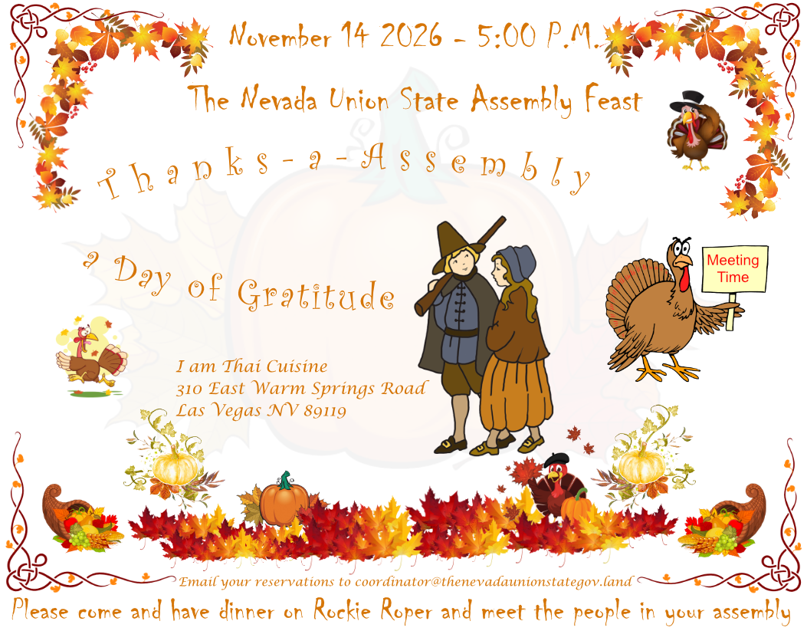
So, please add this party to your list of things to do. I do not care where you live in Las Vegas you are invited to meet your fellow man and woman in the assembly. All I need is a list of everyone that is going to attend so I can make reservation at the That Restaurant. They what a head count. So, please email coordinator@thenevadaunionstategov.land and let us know you will be there.

