The Nevada Assembly Business Meeting
Jun1 11, 2025 6:30pm
Online meetings with Free Conference Call
The meeting link is: https://join.freeconferencecall.com/rockier
This link never changes (508) 924-3161 Store these numbers in your photos or phone and
Please note once the meeting starts if you try to call me I’m conducting the meeting and cannot help you logon, we open the meeting at 5:55pm
6:30pm General & Business Meeting Agenda

Call to Assembly: by a TCCNVA
Bivens Decision:
Purpose for meeting or meeting name: The Nevada Assembly
This meeting is called in honor of the people who are owed a republican form of government and peaceably assemble to restore their government. Your mindful comments are welcome. We welcome any additions you wish to have placed on the agenda. Be it known we believe in a transparent government and a vibrant discourse, therefore if you speak in public and are not in honor you can be held liable for your discourse and actions.
Prior to the meeting please read the following information and be prepared to discuss them:
- Treasurer Status of Michelle/Robert
Banking Liaison Update Channel Program is going through a reboot and the updates for each people and the Assemblies is going to be divergent. Global is reworking their marketing information.

Global Report: The Coordinator Channel to the Prosperity Unions are being paused until individual account side up and running. No timeline on any aspect of Global. At this time, no accounts or access to Prosperity Union are being offered for Assemblies.

Budgeting activities on hold until we know how the Prosperity Union will operate and the timeline.

- State Militia Report
- Committee Reports
Banking
Elections
Public Notces
Oversight
Outreach
PKTF Liason

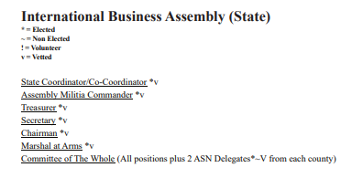

Contact:
coordinator@thenevadaassemblygov.land
outreach@thenevadaassemblygov.land
recordingsecretary@thenevadaassemblygov.land
oversight@thenevadaassemblygov.land
coroner@thenevadaassemblygov.land

Old Business
New Business
Adjournment

