The Nevada Assembly Business Meeting
Online May 28, 2025 6:30pm
Online meetings with Free Conference Call
The meeting link is: https://join.freeconferencecall.com/rockier
This link never changes (508) 924-3161 Store these numbers in your photos or phone and
Please note once the meeting starts if you try to call me I’m conducting the meeting and cannot help you logon, we open the meeting at 5:55pm
6:30pm General & Business Meeting Minutes

Call to Assembly: TNA
Bivens Decision:
Purpose for meeting or meeting name: The Nevada Assembly Meeting
- Treasurer Michelle Schmidt asked for a document for Robert Hale to complete transfer process through chain of custody letter of the $7096 in treasury. The document that is being supplied is Rockie’s vetting letter and affirmations.
- Banking Liaison reported Banking channel being reopened Rockie is working with Anna on it and with GFG.
May 28, 2025
Rockie Roper was voted on to be recognized as a State Coordinator 23 yes (0-0 No-Abstain)
Tamara Amaral was recognized as state co-coordinator and Michell Schmidt as the County Coordinator.

Rockie Roper was voted to be the one Assembly Coordinator to be the Global Contact with votes as 21 - yes (0-0 No Abstain)

State Meeting Rockie Moderator

- Model County Advancements-please see Nevada Model County Report:
- Ombudsman service
- State Militia Report by Shallon Bent forthcoming 6/4/2025
- Transfer of Records to State Coordinator letter needed
- State Director of Licensing Letter. The NDOT contains the DMV. TNA is researching the preparation of a letter notifying State of responsibility to uphold public law and protect Americans for all Right to Travel Issues. This letter will also supply notification to the State Highway Patrol and other enforcement agencies, such as Solicitor General. Letter to Doug Minnich has been sent out, awaiting reply.
- Committee Reports
Banking- State bank account being opened
Elections- Occurring June 11
Public Notices- Pending
Oversight No report
Outreach-Land Commerce Initiative
PKTF Liason

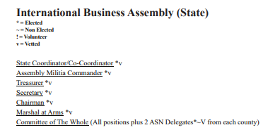

Contact:
coordinator@thenevadaassemblygov.land
outreach@thenevadaassemblygov.land
recordingsecretary@thenevadaassemblygov.land
oversight@thenevadaassemblygov.land
coroner@thenevadaassemblygov.land

Old Business
New Business
Adjournment

