Published May 13, 2025
In this Report
QFS Update
Meetings
Concerning Practice of Propaganda & The Model County Public Square Notice
Applauding Outreach & Active Members
Concerning Agenda & Meetings
Website
Model County is called Continental Congress in Training
PKTF Claim Your Inheritance and Debt Remedy
Concerning Solicitor General
Concerning Rights & Privileges
Concerning Former International State General Assembly Committee & Officers, Appointees
The Elections process is covered in Rescue Mission One report at
International Public Notice: Order Demanding Arrest of Domestic and International Terrorists

QFS Update
May 13
Denise submitted research to Anna requested on the coordinator call May 8 regarding patents on QFS being covered under QES and applied to the USPS bail out compromising security of the nation and unduly increasing surveillance on the People through compulsory utilization of webmail and other mail digitally conforming to the new horizon of eliminating regular postal mail to coerce the People into new form of social credit, a monopoly inducement.
Fomented through the matrix data farms/ Starlink, tied into DOD/Space Command being advertised as a Quantum process, another form of computing(blockchain) and not Quantum at all. These data centers are the new Fort Knox when crypto currency or non-asset backed notes (debt notes) are utilizing human capital through the “Quantum Trust” and “Life Force Value Annuities” and other instruments. This process is known as illegal latching,
The Prosperity Centers through the distribution of prepaid credit is the way of the future and for American State Nationals.
Anna stated in the coordinator call on May 8, 2025 not to acquiesce or sign any government contract concerning QFS or the Trump distribution and this is a psy op to latch onto your inheritance through your consent.
From:Anna von Reitz <avannavon@gmail.com>
To:Denise Mraz <americanfirst@fastmail.com>
Subject:Re: QFS
Date:Friday, May 09, 2025 12:11 PM
Size:25 KB

I have described our relationship with the Federal Subcontractors as a two-lane road. What you are describing is in their lane and they have developed it for their people and their purposes. We don’t approve of it and will continue to develop our side of the road and our banking system for our living people to use.

We are not suggesting that we wish to have a monopoly ourselves — just that we are not in favor of the QFS in the role of a coercive monopoly.

The people of this planet deserve safe, simple, private banking options that are not micro-managed by “government” corporations and interfered with by ANY transfer monopoly.

For a sane and healthy world, we need to maintain our ability to freely trade for goods and services and to use our traditional land-based commercial banks to conduct commerce. Not be forced to “switch lanes” and act as British Subjects simply to live and conduct our own business.

QES and QFS may have valid uses in the jurisdictions “on the other side of road”, but we don’t like the attempts to monopolize banking services and coerce and cajole participation under conditions that surrender the rights and freedom we are owed.

The banking needs of average people are not the banking needs of corporations. Neither should the trade and commerce functions of living people be subject to the regulations imposed on foreign corporations operating in maritime commerce.

Congress does have a role in regulating “interstate commerce” but the intention of that regulatory authority is to expedite the free flow of such interstate commercial activity and prevent such horrors as tariffs applied by one State of the Union against another State of the Union.

There is nothing in our history to suggest that the framers of the Constitution intended for any Federal Subcontractor to “redefine” Lawful Persons as Legal Persons and use this as a means to regulate the form of commerce we may participate in — resulting in a limitation of the flow of interstate commerce instead of its expansion, artificially subjecting us to the foreign law that governs “the other lane”, and creating a self-interested monopoly interest in and control over both public and what should be private commercial transactions.

I hope this gives you an expanded appreciation for the issues.

On May 10, Anna published this article:
http://www.paulstramer.net/2025/05/international-public-notice-two-lanes.html

Meetings
State Meeting Online Saturday May 17 at 6 pm
Clark County Model County Meeting May 17-5:30 pm
All counties are welcome to attend the Clark County Meeting. The only people who may participate are Clark County Residents.
You Have Been Invited to a Meeting
When:
Date and time:
5/17/25 5:30 PM - (US/Pacific)
Duration:
1.5 hours
________________________________________
Conference Call :
Dial-in number:
(508) 924-3161
International dial-in numbers:
View List
________________________________________
Video and Screen Sharing:
Online meeting ID:
rockier
Online meeting link:
https://join.freeconferencecall.com/rockier
________________________________________
Instructions:
At the scheduled date and time of the meeting, dial in to the conference line. International participants will be prompted to enter the access code followed by hash (#).

Concerning Practice of Propaganda & The Model County Public Square Notice
The Model County promotes the American Way of working in honor to uplift and assist restoration to any State National who has corrected their political status or wants to. It is observed that ungainly practices such as labeling documents “More fraud by…..” or naming Committee actions to create unwarranted suspicion or publishing false claims has become a modus operandi of leadership individuals and their proxies, or people acting on their behalf.
There were major whisper campaigns, lies by omission publicized as facts, plagiarism, extortion and worse. This was done to create confusion about the truth and divide people from the mission of the Assembly. Even and perhaps to mortify individuals as they create such. We offer a Public Square Notice beginning today, and as a service to the State Assembly body politic and Model County body politic.
This service may be used for any elections, nominations (ProTem), announcements, or other communication. Perhaps, also lawful notice & legal notice. This service is free of charge, but we ask you consider a donation to your Assembly towards the expense of running the Assembly and the website.
These are attachments emailed to the coordinator and published with the next upcoming Model Report. These Notices will be enshrined in the Announcements and Declarations on websites. The first Public Square Notice attachment is here. Please note Notice Format is Title, Author, Date, Time and your LRO recording number with email contact information. We note mindful PSN is offered and available to ASN/ASC with 928 documented & signed Jural Assembly Agreements.
Applauding Outreach & Active Members
The towns and counties with learned and skilled People are also required by public duty to assist others in knowing how to peaceably assemble. That starts with correcting political status and reaching out to people known and unknown to gather all to restore our lawful government. While attracting people to ourselves by exemplary conduct and knowledge is a crucial first step, certainly humble active assistance in connecting them to claim their inheritance is key. Here are some ways you can help:
- Please feel free to use our hashtag #Assemble4Freedom in comments on social media. It links to our website and even in the case of telling a friend or inviting people to become lawful people, just texting that hashtag to them will connect them to ClaimYourInheritance.com and the Assembly
- Know your duty. The public duty of all ASN is to keep the peace and uphold Public Law. Our website http://www.theclarkcountynvassembly.org/ Top of the page!

Concerning Agenda & Meetings
This is your Assembly created for keeping the peace and upholding Public Law with the Proclamation and Decorum considered. Please note presentations for Agenda item requests may be emailed to the coordinator or outreach and give us a few days, if possible, at least. And if suitable for an agenda action item, will be added to the upcoming agenda now, or in the future, based on the priorities of the assembly.
_________Meetings___________
State Meeting General and Business Meeting Online Saturday May 17 at 6pm link
Clark County Model County General and Meeting May 17-5:30 pm link
All counties are welcome to attend the Clark County Meeting. The only people who may participate are Clark County Residents.
Website
Diagram from PKTF
Home button to 1) Education (existing website)
NEW 2) Services (front/new website)
All other diagrams on websites here.
New URLs listed here.

Model County is called Continental Congress in Training
To brush up on your pursuit of history here’s some American Way Homeschool videos:
First Continental Congress 1774 (ignore the Betsy Ross flag)
https://youtu.be/WJ7o4umxOYA
Second Continental Congress 1775
https://youtu.be/WJ7o4umxOYA

Harassment of the People through Weaponizing & Propaganda on The Assembly
We are America’s only lawful government, but we’re not the government in America. Our federal subcontractors must follow the Constitution.
There’s a growing tide of realization that the 50 State Assemblies are at the tipping point of overtaking the de-facto. Do you really think they want this to happen? And there’s a suppression of the lawful government. The latest thing is to label the lawful Assembly as a District Assembly, throw around news of Anna’s purported approval of their fraud and projecting victimhood when they are the attackers.
This has left the Assemblies confused, demoralized with the fraud gone totally off the rails. We’ve been asked how to handle this situation.
You have a fine and fee schedule. Facts and evidence were sent with proof on Saturday, it was by mistake, but there it is. You have a lawful right to Notice any party who is disturbing your peace, and you can make claims. You may send them a Notice; they gave their email. If you notate a response date and they don’t respond, notice them again. The bad actor leadership trespassed against you.
Now a few people will use this process to unlawfully try and harass the leadership who is actually trying to assist everyone. For example, I am writing this Model Report for you to assist you in your claim of your inheritance. I promise you if anyone tries to send me a notice, I will publish my responses on public notice, even if it’s sent as private communication and its fraud or trespass. I will not allow my time to be wasted on clowns, I’m way too busy building the Assembly. That’s especially true of people making false statements.
PKTF Claim Your Inheritance and Debt Remedy
As a Model County, we have access to the ongoing law education and debt remedy jurisdictional library of PKTF. Please find enclosed debt remedy solutions and the How To Guide.
“There Has Been a Mistake” Letter to the Court ·
Revocation of Election – Stop All Payroll Withholdings ·
Notice of Individual Master File Error to the IRS ·
Appropriated Diplomatic Immunity Passport ·
Global Prosperity Account
“Unincorporation” Papers for My Business · (we no longer advocate PMA since it is a contract, and we don’t contract)
Notice of Liability to the CEO ·
Criminal Information Claim, Notice of Liability Administrative Process for Court
Non-Negotiable Mail (Opened), Non-Negotiable Mail (Unopened)
Reply to my Employee, Governor Mike Dewine
Coming in Model County Report 3:
Discharging Credit card and other bills such as hospital bills

The above remedy can be found at this link---check it periodically for fresh remedy. https://claimyourinheritance.info/wp-content/uploads/2024/11/12-Remedies.pdf
Please see a media outlet at https://claimyourinheritance.info/news-and-tv/
Current federal arrests: https://claimyourinheritance.info/arrests/
Model County is built on the 1776 Union and The Resurgence Project. Catch up on all the latest here: https://youtu.be/pwfo52Wxzy0 and https://youtu.be/n9-VHZyC2j4 . Please sign up for updates on the model county YouTube and Resurgence Project here on the YouTube channel. After you get caught here, please concurrently join us on our meetings, but know this is the path that is being modeled as The Go Forward Plan for Model County, The Clark County Nevada Assembly.
Concerning Solicitor General
Nevada Solicitor General
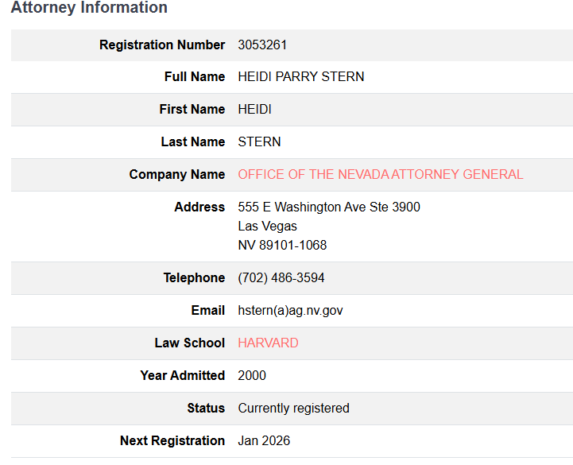
Concerning Rights & Privileges
The Model County adopted this proclamation and this decorum in February 2025, and it is in enforcement today.
How to defend your paperwork, exempt yourself from taxes by No Contract and stop paying , SS, Medicare, Taxes from 17 minutes on https://www.youtube.com/watch?v=pwfo52Wxzy0&list=PLfLAa56-1Nb_WxA_3A173CdJYRDXKCLly&index=8

Regarding Drivers License 42 Minutes
https://www.youtube.com/watch?v=pwfo52Wxzy0&list=PLfLAa56-1Nb_WxA_3A173CdJYRDXKCLly&index=8

Please refer to the attached documents. Decorum & Proclamation
Concerning Former International State General Assembly Committee & Officers, Appointees
On April 19, 2025 TCCNVA adopted the Model County Option iii as the presentment method for standing up the County & State. The pros and cons were discussed in the County Meeting on May 2 and a vote was taken unanimously adopt the Option iii.

iii. County Assemblies work together on standing their National State Assembly same time seat
International State Assembly

g. Review Training Modules for State Assemblies and Advisory Video Series:
i. https://www.youtube.com/watch?v=HMz7vJcsQQI&t=7s: Part 1 of 2: Modules 1-4
ii. https://www.youtube.com/watch?v=v7e5_aSKLN4: Part 2 of 2: Modules 5-8
iii. Playlist of Execution Videos, Advisory Videos, Training Modules:
https://www.youtube.com/playlist?list=PLfLAa56-1Nb_WxA_3A173CdJYRDXKCLly

The above training modules have been observed and is now the plan of action for Model County to follow. The Clark County Nevada Assembly has; therefore, will follow this course of action.
- Follow appointment process to have elections. We have been publishing nominations, holding elections, and proceeding to establish a county based National State Assembly (Congress in Training) and of delegates and electors.
- Seat the International State Assembly properly by populating it through the County Assemblies and how that will look currently is
- Nominations are open Elections are happening soon. The process is publish the roles, nominate, vetting, voting then results posting. If you would like to run for a one year term, please send us a email at
- All current State functions in all levels are currently paused since they are outside the agreement for Model County.
- The current Nominees for each role State and County will convert to Pro Tem Appointee until the elections occur. Multiple Pro Tem Appointments may be accepted.
- Please indicate if you would like to participate and that request will be routed to the vetting committee, demonstrate that you meet the eligibility requirements and then you will be placed on the next agenda for consideration
- elections@thenevadaassemblygov.land
Positions available: Underline positions are ASC status * = Elected ~ = Non Elected ! = Volunteer v = Vetted County Electors and Delegates will be chosen from these positions. All positions except Coordinator requires a Jural Assembly Member Agreement & 928. No vetting is required for committee members, only committee chairs, vetting only needed for elected roles. All non elected roles are nomination/acceptance by Regular County Assembly. Any man or woman that wants to stand up and help coordinate the state or a county needs to stand up and say so. Email coordinator@thenevadaassemblygov.land or coordinator@theclarkcountynevadagov. land and for training. You will be vetted by the Federation and a Clear Check is required. Coordinators are not elected by the Assembly. You just stand up and say you want to help by being a coordinator. After you complete the vetting you are excepted.

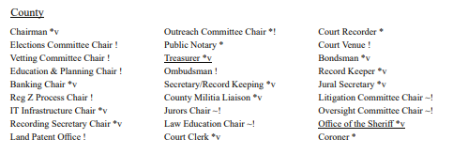
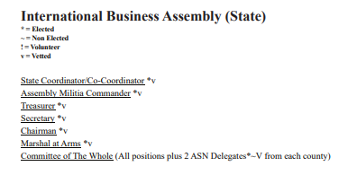
The Elections process is covered in Rescue Mission One report at https://www.theccnvassembly.org/announcements-notices

Notice Saturday, May 10, 2025 Article 5358

International Public Notice: Order Demanding Arrest of Domestic and International Terrorists https://annavonreitz.com/orderdemandingarrest.pdf

Assembly Contacts:
outreach@thenevadaassemblygov.land
oversight@thenevadaassemblygov.land
coordinator@thenevadaassemblygov.land
recordingsecretary@thenevadaassemblygov.land

Website http://www.theclarkcountynvassembly.org/

Common Links
Strategy Task Force Session # Sundays 04:00 Central/05:00 PM Eastern Time (US and Canada) Join Zoom Meeting
https://zoom.us/j/99338071099?pwd=SDN1iMjAAg489tSRcT6V3NRaXzivrK.1
Meeting ID: 993 3807 1099 Passcode: 560423

Model County Alternates with above on Sundays same meeting information

Annas Thursday Coordinator Call 5:15pm
https://us02web.zoom.us/j/86785004785 Zoom App Meeting ID: 867 8500 4785

Annas Assembly Call Monday https://annavonreitz.webex.com/annavonreitz/j.php?MTID=maf593bbfe33bfaa59f4fac189cce18b2 Webinar Link Webinar number: 2596 960 6978 6pm pacific

