The Nevada Assembly Business Meeting
Online May 17, 2025 6pm
Online meetings with Free Conference Call
The meeting link is: https://join.freeconferencecall.com/rockier
This link never changes (508) 924-3161 Store these numbers in your photos or phone and
Please note once the meeting starts if you try to call me I’m conducting the meeting and cannot help you logon, we open the meeting at 5:50pm
6pm General & Business Meeting Agenda

Call to Assembly: by a TNA
Bivens Decision:
Purpose for meeting or meeting name: The Nevada Assembly
This meeting is called in honor of the people who are owed a republican form of government and peaceably assemble to restore their government. Your mindful comments are welcome. We welcome any additions you wish to have placed on the agenda. Be it known we believe in a transparent government and a vibrant discourse, therefore if you speak in public and are not in honor you can be held liable for your discourse and actions.
Prior to the meeting please read the following information and be prepared to discuss them:
- Treasurer
- Restore Treasury with chain of custody letter
- Banking Liaison trained on dashboard
- Model County Advancements:
- Ombudsman service is launching at PKTF. Anyone can submit a request for review if it concerns leadership disputes.
- General assembly pause and repopulate counties
- State Militia Report

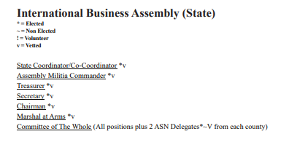

Outreach
Global Family Group Business Package

Contact:
coordinator@thenevadaassemblygov.land
outreach@thenevadaassemblygov.land
recordingsecretary@thenevadaassemblygov.land
oversight@thenevadaassemblygov.land

Old Business
New Business
Adjournment

