The Clark County Business Meeting Minutes
Date May 17, 2025
Playback link XXXXXXX

Call to Assembly: by a TCCNVA
Bivens Decision:
Purpose for meeting or meeting name: Nominations, Appointments and Bank Account
Business Meeting Agenda List: 5:30 pm Please join us for our twice monthly long form County Meeting Sunday with PKTF or catch the recording at https://www.youtube.com/@peacekeepingtaskforce/videos
Strategy Task Force Session and Model County Sundays 2pm Sunday 5/18/2025
Refreshing to hear the PKTF is supportive of public notice to officials for accountability when dereliction of duty occurs. All officer holders, or positions of public duty, must be on the LRO. It was reviewed on this call the latest collusion of State Coordinators & County Federation Vetting Chair who uses other State current Coordinators to vet new coordinators was/is stalling new coordinator vetting. This is being fixed. Teri Sahm, federation, has no jurisdiction in the naming or promotion of any assembly as a District Assembly.
Concerning Rockie and Denise
Rockie and Denise are providing exemplary service and are well regarded by the PKTF, are in good standing and there is no “recourse” by Anna Marie Reizinger, our Commander- In –Chief, to remove Rockie and Denise, or remove their Seals or limit in anyway their participation in the Assembly. That was a lie published by the author of the “findings” of the Committee.
This audio link on Claim Your Inheritance https://claimyourinheritance.info/ Play the link under the video with no sound to hear the latest message from Anna Von Reitz. The Clark County Assembly is listed as the approved Assembly to access your Inheritance and restitution, payment for your own natural resources and abuse of fine, fees and taxes.
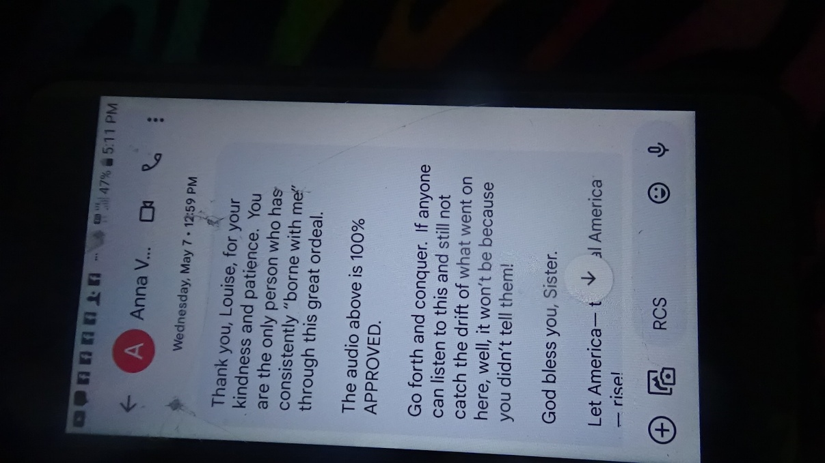
The Clark County Assembly led by Rockie Roper and Michelle Schmidt is a federation recognized county assembly. No State Assembly Coordinator and/or Teri Sahm can never declare any authenticated Assembly as a District Assembly.
The Nevada Assembly State Oversight Committee run by chairwoman Jill Horsley exceeded her jurisdiction, and committing fraud on all assembly members publishing false information concerning Rockie and Denise which slandered them and the Assembly, confused ASN and undermined their good work and public trust. This is being addressed by PKTF and also the committee members will be receiving notices concerning their conduct, fraud and trespass on The Clark County Assembly, and Rockie Roper and Denise Mraz. 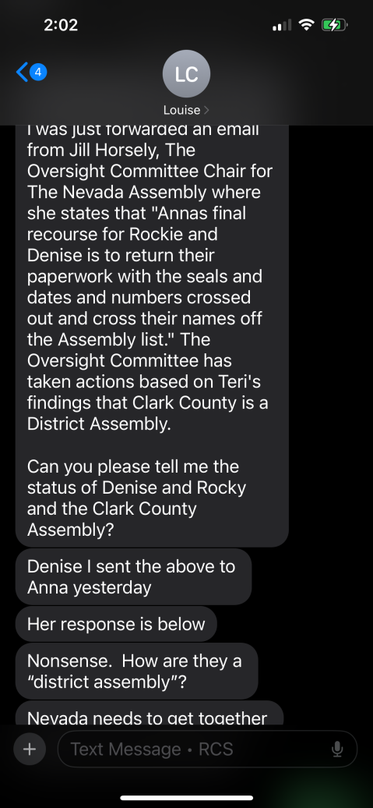

Please also note Mark Seilstad, Sue Hulsebus, and Doug Hulsebus are not set up right in the LRO. Since they are not set up right in the LRO and Master Record presence, they can never hold any office until this is corrected, and Mark was asked to step down in December for investigating an ASN. The other two people committed other crimes.

Nominees can be appointed for positions

It was approved Convert all Nominees to appointees until Elections can be held June 17,2025. Denise will contact all previous nominees by email, and they may fill out a nomination form, a jural member form signed and the form can be recorded at the election on June 17,2025 at the in-person meeting. Please be advised you must be listed on the LRO and verified to run for any office.
Seal Approval
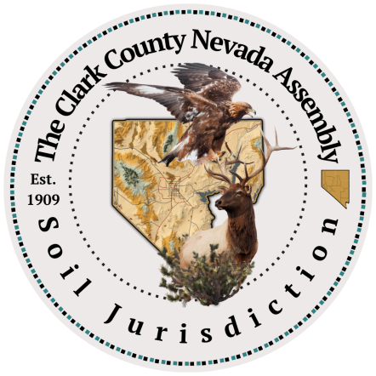
Mock trial June 11 Location to be determined 6-7pm
Please let outreach@theclarkcountynevadagov.land know if you can participate in the mock trial
30 people are needed plus Sheriff and Deputies
16 jurors
All Jural Assembly Positions (9)
4 participants Ombudsman

Model Report Discussed.

What’s in your Travel Packet? Indemnity Bond Body cam 928s Case Law. The sheriff mentioned showing your passport card if you have one, so you avoid contracting with LEO. You may also give them a copy of your fee schedule. Anything they ask you for, do not consent. Cooperate with showing an ID.

A Clark County Assembly Bank Account should be opened with Tom Vargas, Michelle Schmidt, Rockie Roper and Scott Johnson at the Clark County Credit Union with a $110 deposit of county funds no later than June 1, 2025, each person shall be a signer on the account.

