Minutes of The Clark County Business Meeting
Date April 19, 2025
In person at 5111 Boulder Hwy Las Vegas NV 89122 in the Silver City Room and Online meetings with Free Conference Call
The meeting link is: https://join.freeconferencecall.com/rockier
3-4pm Business Meeting Link
https://nvstate.myqnapcloud.com:8443/share.cgi?ssid=bcc2321b38084e6ea4ff9b2368c217c8

Call to Assembly: by a TCCNVA
Bivens Decision read three times:
Purpose for meeting or meeting name:
Business Meeting Agenda List: 3pm
This meeting is called in honor of the people who are owed a republican form of government and peaceably assemble to restore their government. Your mindful comments are welcome.

This is from Anna's article 3014

Those who are employed by the Federal Government or the Federated State of State Government should, generally speaking, be participating in their own District Assembly, and while they are welcome as State Nationals to attend public meetings of the State Assembly and share their opinions about in-State issues, they are not eligible to function as State Citizens and are not eligible to vote on or influence interstate decision-making until they retire or otherwise sever their obligations to the Federal Government.

Home School is on the 19th too. Please join us in from 9 a.m. to 3 p.m. meeting home school people. AWH was asked by 8 platforms to submit information or will be contacted. Approximately 175 people received information on AWH and about 50 people total attended the meetings or contacted us online. Roughly 450 people accessed the QR code due to efforts of Jennifer Phillips distributing promotional materials.
Where 5111 Boulder Hwy Las Vegas NV 89122 in the Silver City Room
Concerning the Jural Assembly Form
Motion 25:4.19.2 Adopt the Jural Assembly Form
Motion 25:4.19.1 Require all members of the Banking Committee, all appointees and all electorate to sign the jural assembly form. All money handlers to sign the Jural Assembly Form.
Resurgence Project-PKTF 40min-64min
https://www.youtube.com/watch?v=E-1xkvSKE10
The original State Pillar approach is being reset in a think tank project spearheaded by Louise PKTF to seat the County as Nation/County. People, Town, County, State Jurisdictions are being approached from our original ground up grass roots.

1)Seating your County Assembly is important to provide services for our Americans on the County and all the power rests in the People.
2)One County will be chosen in each state and one county will be seated with the State. The state Compositions with vetting are changing the coordinator. State officiates/appointees will be on County then also State.
3) County Assemblies that have strong positive indicators are the County hitting the milestones of Outreach, Pillar building, events, banking and governmental recognition, such as de-facto recognizing us.
4)How does the County Assembly interact with State? More details to come. From The County, we will create the State through delegates. All State leadership as we know it is unfolding in this model.
5) Ombudsman and Conflict resolution is necessary to pave the way, which is why we are working with the Ombudsman.

Motion25.4.19.3 Adopt the proposed think tank structure of
;people, Town, County, State structure,
; That towns may work together to create a body politic until such time as they wish not to cooperate,
; and that Clark County is comprised of many towns, both incorporated and unincorporated,
; That Clark County adopts a spirit of cooperation of banking and government services for counties and adjoining counties within the State of Nevada as they see fit to join with Clark County,
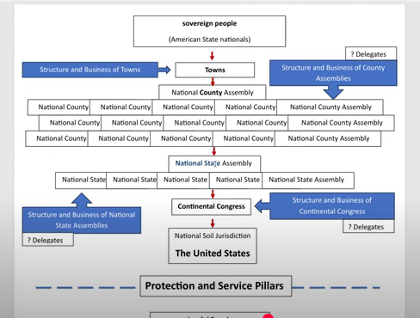

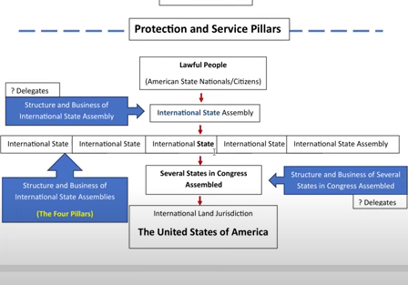

-----New Vetting procedure-------
Everyone needs to be vetted again.
Vetting Lead: Each Assembly needs to have a Vetting committee. Per the Continental Marshals the Coordinator and Treasurer as well as a Vetting Lead need to be vetted by the Cont. Marshals. Here is the Cont Marshals webpage which contains the intake form https://continentalmarshals.us/vetting-form/.
Once your Vetting Committee is established- your vetting committee will vet those people, such as anyone handling money, confidential information, assets, records et alia.
Motion : Need to elect a vetting lead County & State. All officials are going to be vetted again.
Committee Reports and Decisions:
TCCNVA
800 North Rainbow Blvd Ste 1o6- 161
Las Vegas, NV 89107
Phone Number 775.365.6359

Banking text group: Text Denise to join 702.722.8489 on text and Signal
Outreach activities Merchant banking outreach group .
Recording Secretary: Current Recording Secretary people and new people, status of Tom, Ray, Fitu, Lora, Tamara.
Vetting Lead: Nominations open and filled by Robert Lentkis

