The Nevada State Business Meeting
Date March 30, 2025
In person and Online meeting with Free Conference Call
The meeting link is: https://join.freeconferencecall.com/rockier
2pm-4pm Business Meeting Agenda
Dean’s Place Restaurant 8355 Dean Martin Dr 89139 (Near Bass Pro Shops)
Updated 3/28/2025 see below
Call to Assembly: by a TCCNVA
Bivens Decision:
Purpose for meeting or meeting name: Review proclamation summary
Updated Business Meeting Agenda Items
This meeting is called because the people are owed a republican form of government. This is going to be your chance to speak up and determine how your government is getting organized.
- No confidence vote based on evidence and ongoing chaos by Sue Hulsebus, dependant of Doug, creating controls by weaponizing the assembly and all meetings. We have documented that no paperwork showing Sue was vetted by the Federation. The only vetting papers of Sue is from the vetting committee with Shane being the chairman and he was not vetted by anyone. No one signed his vetting approval. Anna Von Reitz in a call Feb 13,2025 told family members creating discord in Nevada to step down and she asked us to tell them that and we did on Feb 16,2025. No other family was creating discord but them.

- No confidence vote on Doug Hulsebus as Marshal-at-Arms since he, due to his recently disclosed but formerly undisclosed, dual citizenship working as a fire station manager who’s supervisor is the Fire Marshall on The Nevada State Police of the Red Rock Station on TMFD, his egregious conduct and not working in honor by denying a republican form of government by weaponizing meeting controls, gross malfeasance and breach of trust of office, hostility and disturbing the peace of the assembly. His Fire Department role was not disclosed in his vetting, and neither was the fact he works for Big Pharma. Also Doug was vetted by now retired firefighter Shane, a non-vetted person. Through Anna’s teaching we only allow our government to be run by people exclusively on the Land Jurisdiction. Not a dual citizen.

- The body politic will also have an opportunity to learn the truth on the alleged inflammatory rhetoric concerns and Rockie will be able to present the truth on screen proving Kathy Krindler, PKTF and as an ASN on Nevada, released a chat commentary page that was later presented to the Nevada Assembly body politic to frame Rockie as an unfit leader. Rockie will show the words on the page were changed and new and different words were inserted then shown to the body politic by Sue and Doug. The materially changed evidence made people believe a false narrative. Doug then declared Rockie censored. Rockie then wrote the truth in a forum of other coordinators who are also having issues, in order to resolve the issue, that he was getting blocked by the Coordinator and the SC/MAA are married. Our Assembly has a right to decide how the actual facts should impact the ability of Rockie’s leadership. The Assembly has the right to evaluate the truth vs. a falsification cut and paste document presented to make people believe a lie. Rockie has consistently sent many emails to Sue for the purpose of solving issues, but she has no desire to solve problems. These emails also went to Teri Sahm and Anna Von Reitz. Sue has weaponized the system and process of vetting, the list serve, and has acted with malicious intent to harm which ultimately harms the entire assembly. A no confidence vote will also be brought to the floor.

This is your assembly and your chance to build this government we all need and are obligated to uphold the peace. We, the people, have control of our Forward Plans to establish our lawful government and hold our elections for the protection of the people. And voting to establish a lawful government in Nevada is your right and duty.
So, if you choose not to attend you are okay with the way things are going and then you are letting the ones that do attend have the say in the way The Nevada Assembly is built.
PLEASE EVERYONE ATTEND AND SPEAK UP. Contact Rockie.Roper@tccnva.org if you know anyone that needs an updated email address.
How the voting will take place
Everyone will be muted on entering the call and when the time comes for everyone to have up to their 5 minute time to talk, and they have their hand up will have 5 minutes to speak their minds and then after everyone has had their 5 minutes, we will be voting on the three issues. If anyone online tries to stop or delay this meeting they will be muted for the rest of the meeting. If anyone shows up at the meeting and is unruly, they will be asked to leave.
You will still be able to vote if you are online and if you stay around outside the meeting we will take your vote.
The vote will be taken with transparency. If you vote yes and wait for the count and after that count you will put your hand down. Then the No vote, then absentia the same.
We will give the results after the counts.
This will be a temporary count in tell the voters are match to the LRO to make sure they are a ASN or ASC. ONLY ASN and ASC can vote.
Notice to Agents is Notice to Principals; Notice to Principals is Notice to Agents.
New Business
Go Forward Plans
Open to the people.
Update 3/28/2025:
Sue wrote and sent to The Assembly at 3:10pm the following:
Some of you may have received an invitation to a "Nevada Assembly Business Meeting " from "The Nevada Assembly" scheduled for March 30th. This invitation is fraud on its face as it was called by a county level Assembly Member holding a probationary position who did not pass vetting on the State level. Fraud vitiates all ab initio. In addition, the entire Assembly was not invited. I did not receive an invitation and am the subject of allegations made in the invitation. There is a procedure for conflict resolution and no attempt was made to resolve the allegations addressed on the invitation appropriately. Everything done at this meeting is void for fraud.
by: Sue Hulsebus©
A living woman on the land and soil
Nevada Coordinator
The Nevada Assembly
The United States of America (unincorporated

Update 3/28/2025
Rockie’s Response:
- Sue Hulsebus is an illegitimate Coordinator, she is posing as a coordinator. Her signature block should say Federation State Coordinator, instead it says Nevada Coordinator. She is neither. Sue has full knowledge her fraudulent vetting makes her coordinator claim illegitimate and; therefore, all she does and did is null and void, in fact her status and jurisdiction make all she has done ab inito.
- She received an invitation and I possess proof of her invitation as well as Doug’s being electronically received. However, she states that since she has not received an invitation this meeting is null and void; therefore, because she has stated that a lack of invitation voids a meeting, then we have the list of many people who not only did not receive invitations, or experienced electronic interference; therefore, this has happened every meeting so then by her own declaration all her meetings are null and void because we are all involved in every meeting and the decisions impact all of us but at least one person was left off the list with intent to deny the people the right to self govern, so everything The Nevada Assembly has done is null and void.
- We are being denied a republican form of government and denied self- governance when the truth is obfuscated and the corrupt state leadership mirrors kings and queens with empirical or monarch like authority who dishonor us, especially when they have no clothes.
- Fraud by malfeasance and breach of public duty and gross breach of trust is a trespass and denies us the right to self govern. Our Prudent Man doctrine calls us to stop all and any acts that harm our ability to self govern and protect our trusteeship of our trusts and interference of right to peaceable assemble.
- The chaos created by Sue and Doug are driving people away from The Assembly in disgust or simply giving up which is interfering with the rescue mission of The State Assembly.
Chat Log:
https://nvstate.myqnapcloud.com:8443/share.cgi?ssid=a0ea5ff7fe9d4d8ba7a87bfa98246e6d

Image below of chat submitted by Kathy Krindler with Rockie’s full comments deleted.
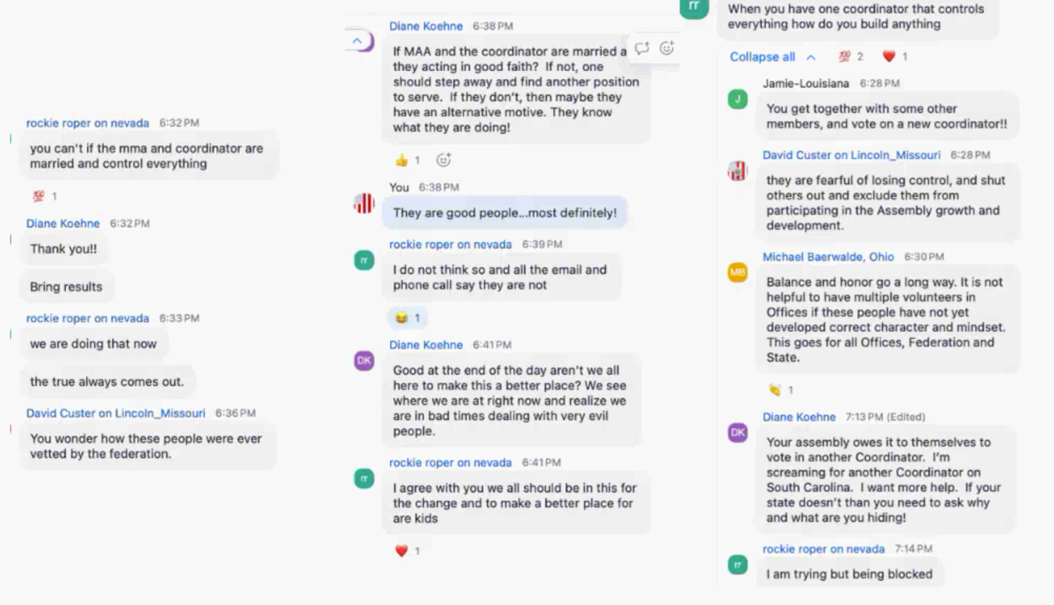
Rockie’s 1:35:36 comment
removed
After David Custer 6:36 Comment, Rockie’s Comments at 1:35:36 “they was not is one problem” referring to the fact SC and MAA were not federation vetted was deleted by the presenter of this document put forth by Sue Hulsebus, an obvious attempt to hide fact that they were not vetted which is fraud. Since they are defacto and since they have committed fraud, this exposes them to anyone in the Assembly wishing to pursue them for this trespass and implicate their collaborator Kathy Krindler who states 6:38pm under You: They are good people….most definitely.

The presenter materially changed the Chat screen capture indicating they were not federation vetted, which is fraud and trespass by defacto individuals.

At best, and only if it could be presented that at some time a public meeting with a listserve evidence indicating all people had been invited to vote Sue Hulsebus as a coordinator that is not federation based, could she possibly be a coordinator. However, she has said many times herself she is a federation coordinator and the only way she can be removed is if Anna removes her or she steps down. That is false.

Denise Mraz kindly asked Sue and her collaborators to step down on Dec 9, 2024 in a private email Sue chose to make public on 1/31 because Denise had discovered Sue and Doug had committed fraud on the Assembly and that they were dual citizens.

Basically, and to simplify the matter for all those who are still confused, Nevada has a coordinator named Sue Hulsebus who is totally illegitimate, and all those who support her will also be brought to task.

Here’s the time stamp log of the entire chat:

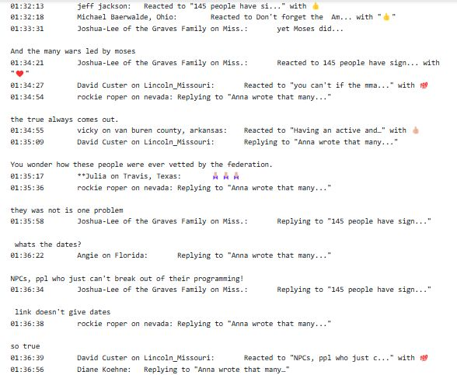

Notice to Agents is Notice to Principals; Notice to Principals is Notice to Agents.

