The Clark County Nevada Assembly Business Meeting and General Meeting
Date: Friday March 30, 2025
The meeting link is: https://join.freeconferencecall.com/rockier
Call to Assembly: by a TCCA
Bivens Decision: Read by Assembly Member
This meeting will discuss the organizational chart and the necessary steps left to stand up Clark County and Nevada Assembly.
Bear in mind the whole purpose of our receiving funding is to self govern and if we aren’t stood up we won’t be receiving our funds and that is an absolute fact. Anyone telling you otherwise is bearing false witness to the truth of the matter.
Please email any questions you have to rockie.roper@tccnva.org in advance so he is sure to address questions in his presentation:
There will be a Q& A afterwards as well. Please email Denise or Rockie if you want to added or deleted to the denise.mraz@tccnva.org.
Call for Nominations
Nominations for State Elections Closing May 20, 2025
Elections June 22,2025
Training and job descriptions are found on the link below and in various America! Some Assembly Required videos https://www.youtube.com/watch?v=o3xi8M_SYXg and as they roll out which is ongoing. Specific role videos will be loaded into Open Project as they come in. Please request an open project login from Denise.
If you haven’t already done so please complete SIA Training on TASA website and load the completion certificate in your LRO.
Mock Trials will begin around April 22 for Jural Assembly.
Current activities for Nominations include all Roles on State Org Chart. Nominees are asked to submit Bios to denise.mraz@tccnva.org .
The following roles require basic background checks which will cost about $60:
Coordinator County Sheriff MAA Militia Commanders Treasurer Justice Bondsman
The following Roles require financial: Bondsmen and Treasurer
Changes to Org Chart will be made upon voting at the meeting: All Roles are open for election, chart reflects current nominees.
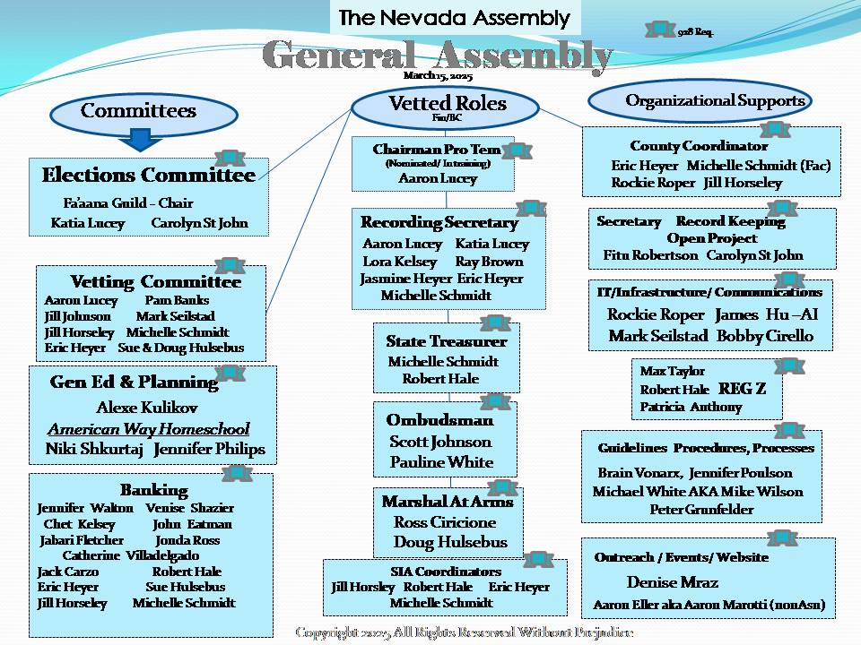
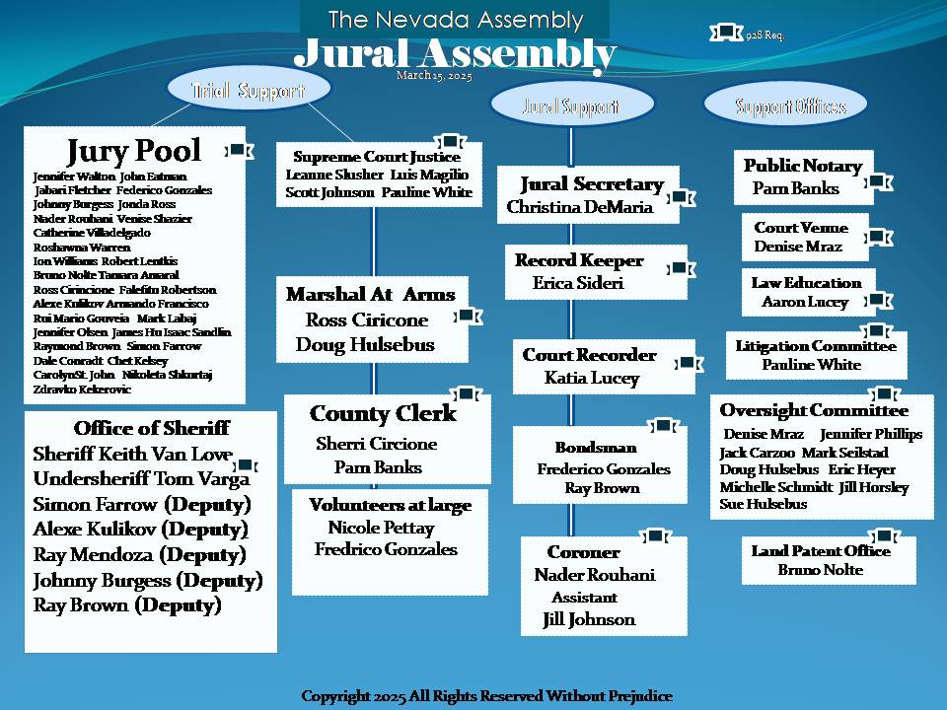
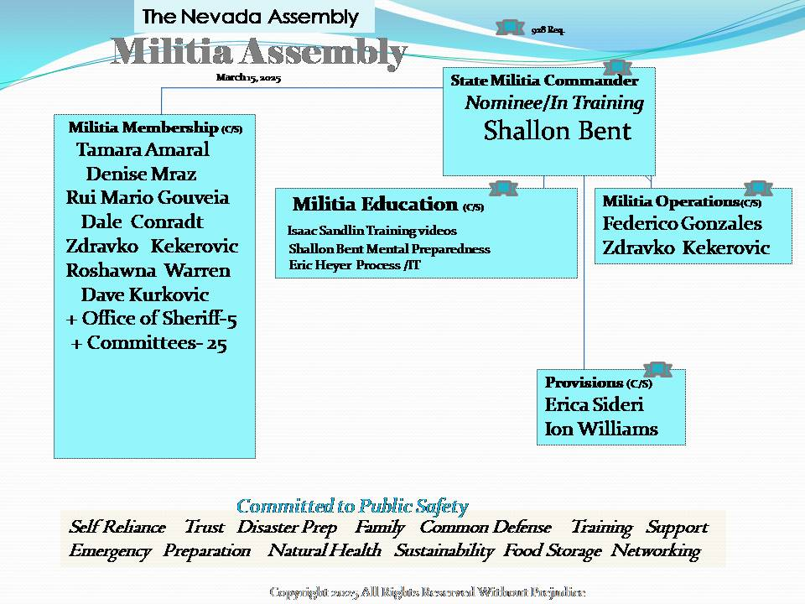
Global Bank
There has been Global Bank announcements on the last 2 Monday night webinars, here’s the link for Monday in case you haven’t been listening lately.
https://annavonreitz.webex.com/annavonreitz/j.php?MTID=maf593bbfe33bfaa59f4fac189cce18b2
Webinar Link Webinar number: 2596 960 6978
If the Event site asks you for a password, the password is: anna

AmericanWay Homeschool –Spring Rescue Mission Event
Marketing through memes, printed material, and tutor/Nanny websites geared to Homeschool families (400 teachers) on just one site!
Niki and Jennifer are creating original flashcard decks. Please sign up for a 2 hour shift
Tables
- PKTF- ClaimYourInheritance.com Keeping The Peace

- General Assembly/Federation Baby deeds/ recording/

- Militia- Make slingshots and plant sunflower seeds

- Banking- Global 528 prosperity accounts and AFD (Cameras)

- Jural Assembly and office of Sheriff how to autograph your name.
(Red ink pad thumbprinting) (Fluoride Notice)

Art Exhibition: Poetry/Essays/Comedy Film Shorts Original Art

To date here are the most recent 4 pillars trainings electronic documents from the Ohio Assembly for your review and convenience and there are role descriptions in them for the org chart.
https://link.storjshare.io/s/jvf6pvp2n2bs2k2s4yfog7q3oz4a/gened/General%20Education/Ohio%20shared%20docs/
Published 3/28/2025

