Minutes of The Clark County Nevada Assembly Business Meeting and General Meeting
Date: Friday March 14, 2025
Minutes published March 15, 2025
Online Meeting link https://nvstate.myqnapcloud.com:8443/share.cgi?ssid=f4a5978bf57d433c94a13e9d44736620

Call to Assembly: by a TCCA
Bivens Decision: Read by Rockie Roper
This meeting discussed the organizational chart and the necessary steps left to stand up Clark County and Nevada Assembly.
Bear in mind the whole purpose of our receiving funding is to self govern and if we aren’t stood up we won’t be receiving our funds and that is an absolute fact. Anyone telling you otherwise is bearing false witness to the truth of the matter.
Please email any questions you have to rockie.roper@tccnva.org in advance so he is sure to address questions in his presentation:
All and every person on these organizational charts has agreed it is their public duty to uphold the law: https://annavonreitz.com/yourpublicduty.pdf
All of our law for every position is based on Law of Kinds: https://annavonreitz.com/lawofkinds.pdf
Please email Denise or Rockie if you want to be added or removed from the chart to denise.mraz@tccnva.org.. Please note, we were diligently advised against family members being in conflict of interest and it came up a month ago in a coordinator call between Anna and Rockie (https://www.theccnvassembly.org/wp-content/uploads/2025/02/announcement-2-13-2025-acting-county-coordinator-seeks-state-coordinator-roled.pdf ). I made a note of some of our family members that did not have the last name, and I did so to keep track of the over 200 names to be sure that we were following Anna’s instructions to avoid conflict of interest. I accidently listed a name wrong on the chart, and this was the genesis of why I relabeled the people then transcribed the relabel-Woops!And I’m deeply apologetic that the wrong name was used. It is corrected now! A quick note or text in a chat is all I need to get it resolved, I may still have misspellings; in any case we will make a running list of these items and then keep updating as we go along.
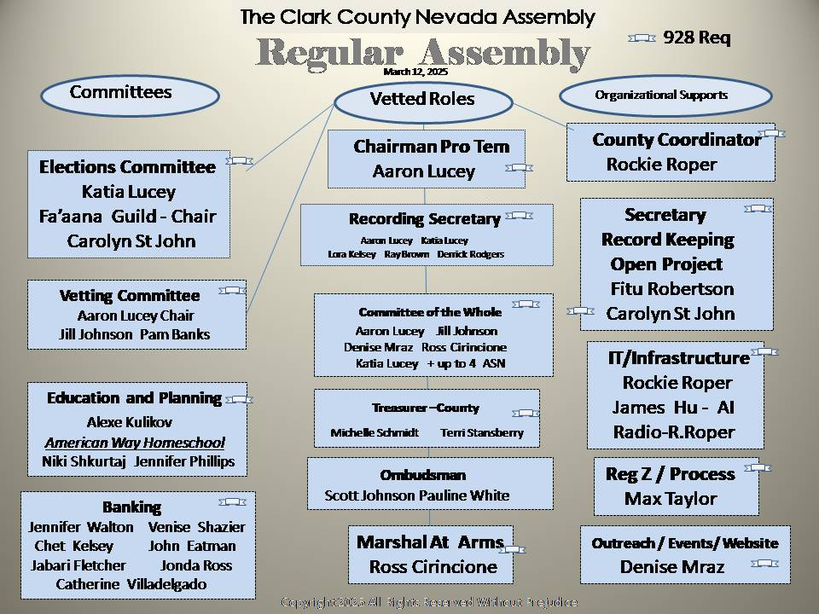

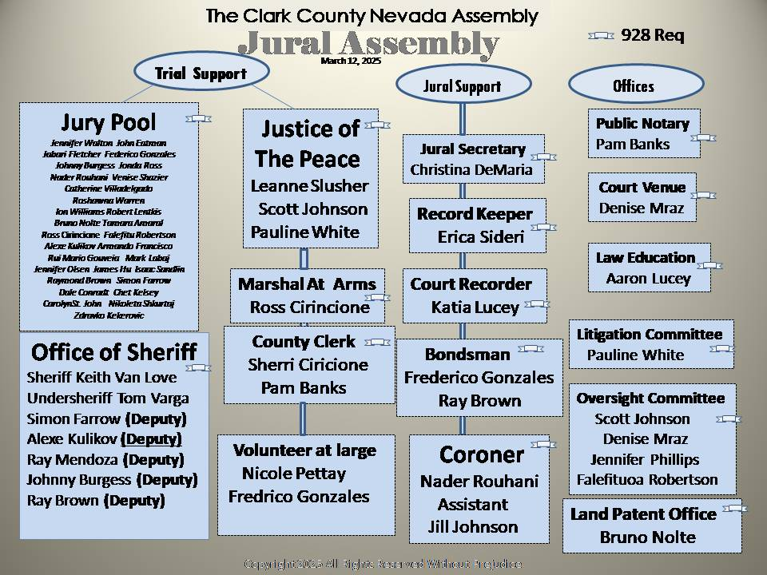
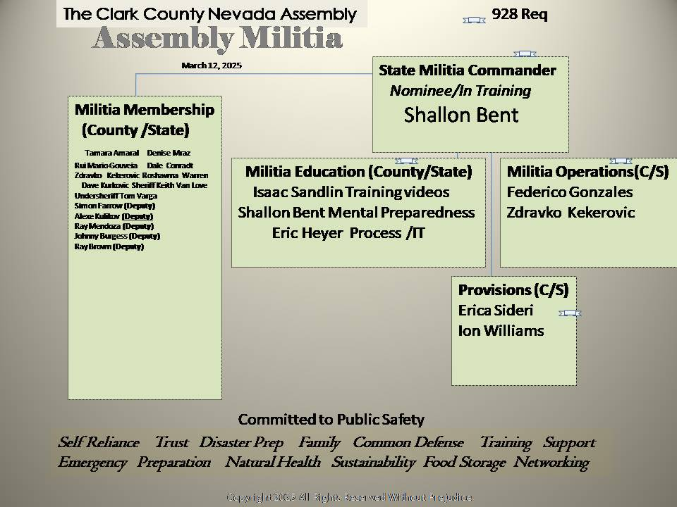
_______________End of County Org Charts______________________
State Org Charts using information published from 3/7 and 3/9 from State as sent to various Assembly Members. To date, the State has not responded to numerous requests from a variety of people in The Clark County Assembly for organizational charts.
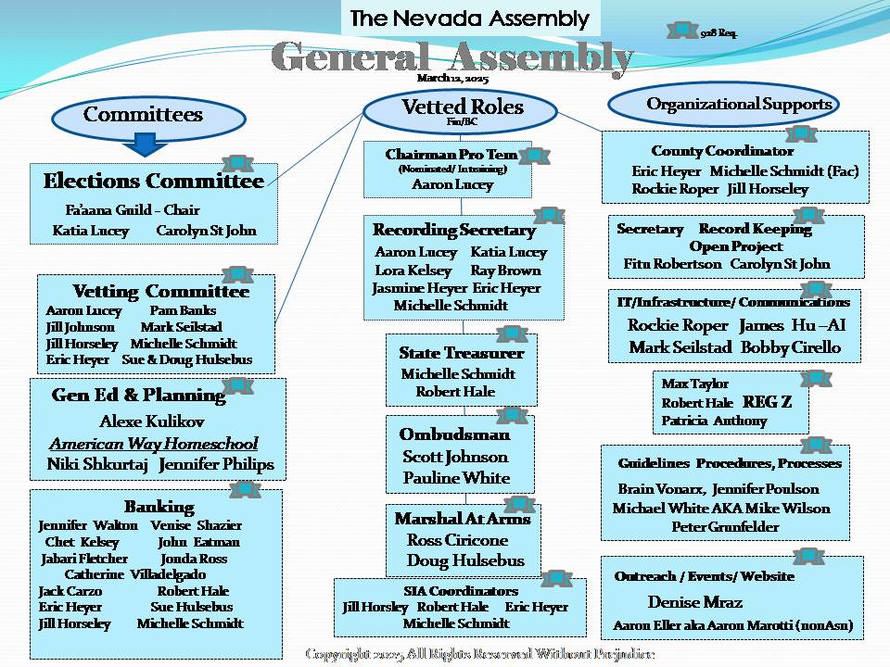
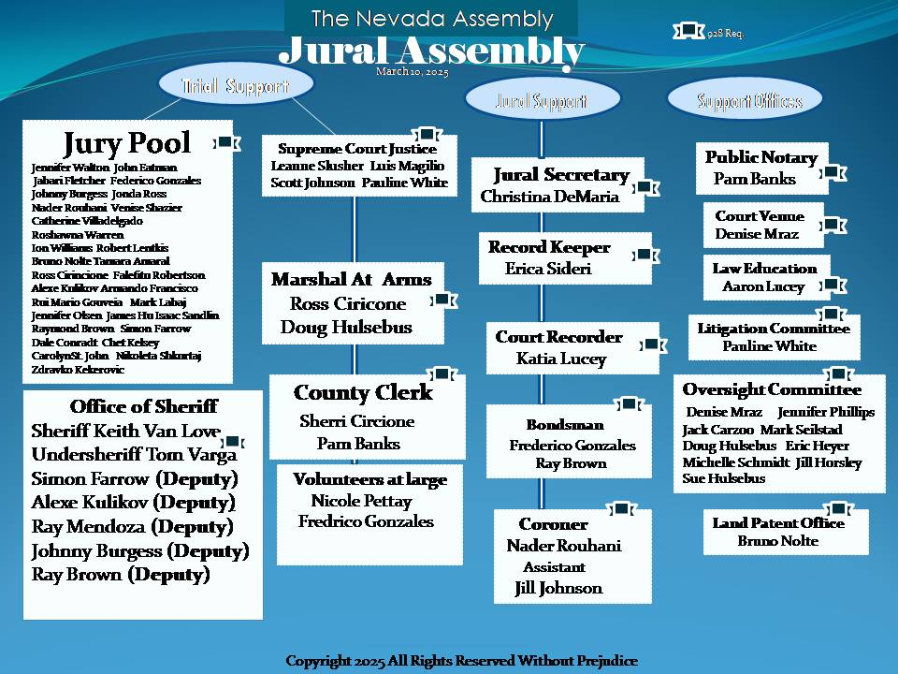
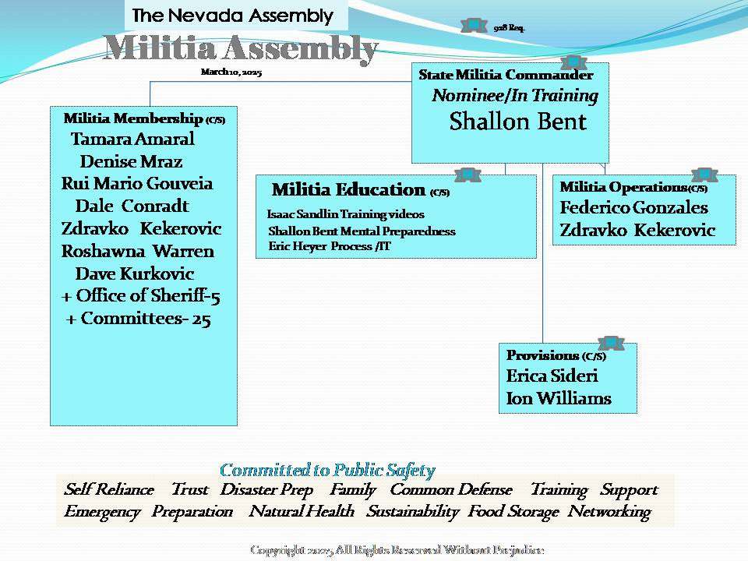
All the County generated org charts are currently dated, but they haven’t been voted on yet. The nominees and volunteers in training may not have completed all their requirements for the positions yet. The Chairs are a commitment but the volunteers may ebb and flow and don’t require a vote; however, they do require 928.
At this time, the State has failed to host business meetings with access by and for the members to bring items to the floor and nominations for a vote ; therefore, they are preventing us from restoring the government because they are blocking the free speech of The Assembly.
Further, the State have weaponized process and procedures with unduly and arbitrary standards by which subjects can be brought to floor, hampering the ability of the county to go foreward peaceably.
Further, The State Coordinator had a Vote of No Confidence brought against her in the previous Clark County Assembly Meeting February 2025 for denying the Assembly the right to a republican form of government, weaponizing process, removing people without authorization, gross breach of trust and erasing records and not keeping records of The State meetings which is also the role of her husband MAA and ;therefore, the issues are being addressed by reports through the Criminal Incident Reporting process for Gross Breach of Trust and this level of negligence constitutes fraud and trespass in American Common Law.
Vetting/Election
The following org chart positions requiring vetting and SIA training are here in How To Build An Assembly: Page 60-81 have all the vetting requirements for every position in this link below:
https://login.thearizonaassembly.org/wp-content/uploads/2024/10/HowBuildAnAssembly.pdf

Glossary
Glossary of terms is like an interactive flash card deck, get it here: https://searchannavonreitz.americanstatenationals.org/glossary-of-terms/

Reminder Sunday meeting with Lisa Schaeffer of Ohio Assembly 3/16 3pm
One more reminder is that Lisa Schaffer is having a zoom meeting going
over the 4 Pillars and all (state wide) is welcome to join the meeting
on March 16 at 3:00 p.m.
Aaron Lucey is inviting you to a scheduled Zoom meeting.
Join Zoom Meeting
https://us06web.zoom.us/j/83918466206?pwd=EWLZoaKZs2LmUITbDo8cOTxBqCE3qC.1
Meeting ID: 839 1846 6206
Passcode: 233235
In this meeting we would like everyone to take notes and at the end of
the meeting we will go over everyone's notes to get the answers you
need. If we keep stopping to answer question the meeting will be real
long, so we are trying to keep the time down for everyone. Thanks for
helping in building the 4 pillars.
https://link.storjshare.io/s/jvf6pvp2n2bs2k2s4yfog7q3oz4a/gened/General%20Education/Ohio%20shared%20docs/ This document may need a passcode and after the 3/16/2025 meeting with the state we will hopefully have the universal code. This is the storage link where TOA is uploading the 4 pillars updated documents periodically.
For consideration at the next meeting;
Outreach Vector, Social Media Membership
For consideration on future Organizational charts- becoming a social media membership subscriber
https://asndirectory.com/membership-levels/

Final Note from Denise
As I traverse the wide range of knowledge of Anna Von Reitz, I come across good reminders and this article is the orginal document from which Saul Alinsky took his rules for radicals and added his evil twist, but it’s always been here for us to red since the 1600’s. Our defacto government considers “no virtue” a virtue and this is the basis upon which all their training is founded: https://annavonreitz.com/knowyourenemy.pdf

3/15/2025 12:30pm

