Minutes of The Clark County Regular Meeting
Wild Sage Ranch
14975 Mater Mea Place, Mountain Springs, NV 89161
Date February 23, 2025
Online meeting & in person meeting with Free Conference Call
4pm Regular Meeting with 2 online attendants Agenda
Call to Assembly: by a TCCNVA
Bivens Decision:
Purpose for meeting or meeting name: Review proclamation summary

The link for the meeting is here: https://nvstate.myqnapcloud.com:8443/share.cgi?ssid=d2b19c3571084c8aaa1f700a070f73b1

Memes

Memes for the social media as promised-don’t forget to put this in comments on social media everywhere and also please use our #Assemble4Freedom hashtag:
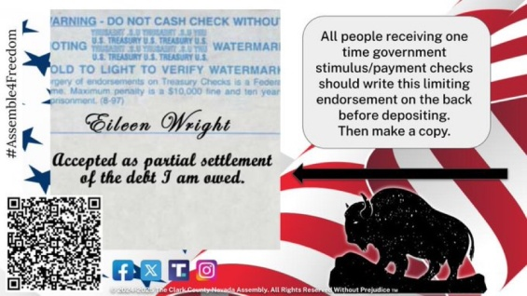

General Assembly Meeting 130-2pm
Welcome New Members and Nye County
Discuss volunteer positions in all and every committee. Several people have asked for a list of openings, there are many because we can have multiple people in one slot and people can train for multiple roles and should. Especially Jural assembly!
Here’s where we are finding that and so can you, see the role decriptions on this most updated 4 pillars info:
https://link.storjshare.io/s/jvf6pvp2n2bs2k2s4yfog7q3oz4a/gened/General%20Education/Ohio%20shared%20docs/4%20pillars%20n%20Committees-Ohio.pdf?wrap=1

Open Project Overview
If you would like access to Open Project to see what is in the folders, please email Denise and I check this email every few days and I will get you a link: denise.mraz@tccnva.org

Fundraising. The home school event will mitigate for cost of room

Review of social media and giveaways- social media memes are attached

Milita comments by Shallon Bent –Shallon is the State Militia Commander and lives in Nye county

New Business
Volunteers are needed to put business cards on the NASCAR parked cars March 14-16, County Fair parked cars April 7-9and anywhere else there is an event.

Michelle Schmidt heard that Sue Hulsebus was contacted by Global Bank and the letter indicated that Global will be running everything through The Coordinators. Michelle asked is something could be done through the Jural Assembly Sue Hulsebus has not formed a banking committee or told anyone about the 2/17/2025 letter, and it’s 2/26/2025.

Denise found out about the letter to Sue on 2/17/2025 when her coordinator friend from another state sent it to her on 2/19/2025.

Also, Denise Mraz emailed Sue Hulsebus state Coordinator on 1/23/2025 and other times and stated as the outreach coordinator she needs to be apprised of all and communication that affects The Clark County Assembly and there was no contact on this banking letter and other links/matters. Shortly after, on 1/31/2025, a slanderous defamation letter with private communication was sent to listserve@nevadaassembly.org by Sue Hulsebus and The County Assembly was ordered by Sue to shut down the office and other commands. However, the County Assembly is not run by Sue Hulsebus so this trespass was felt by all and every Assembly member.

Further, members received this horrifying character assassination email, but have consistently not received links for meetings to help them gain knowledge. And the people have a right to peaceably assemble through notification of any State meetings. They are owed a republican form of government at all times.

A vote was taken and a unanimous consensus was observed to contact the Jural Assembly with a letter stating our concerns and it would be sent to Sue Hulsebus State Coordinator this week.

Denise Mraz
702.722.8489
February 26, 2025

