February 25, 2025
Regarding the State Coordinator withholding of information on Banking.
Letter to The Committee of The Whole
Aaron Lucey
Katia Lucey
Denise Mraz
Michelle Schimdt
Jill Johnson

At a meeting on 2/23/2025, of The Clark County Nevada Regular Assembly a consensus was determined to refer an important matter to The Oversight Committee.
It came to the attention of a Clark County Assembly member on 2/20/2025 a letter had been issued to State Coordinators on 2/17/2025 and the knowledge was shared to the Clark County Coordinator that Global Bank had notified all State Coordinators to notify their Banking Committee and Co -coordinators of the following:
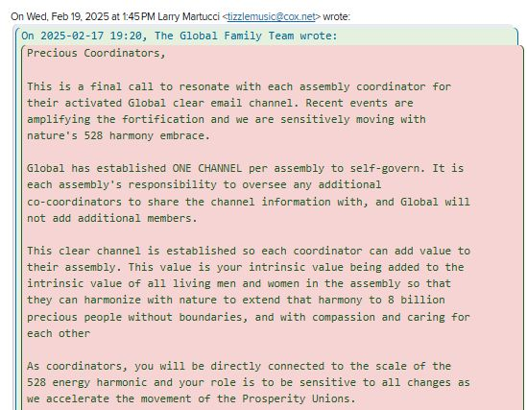
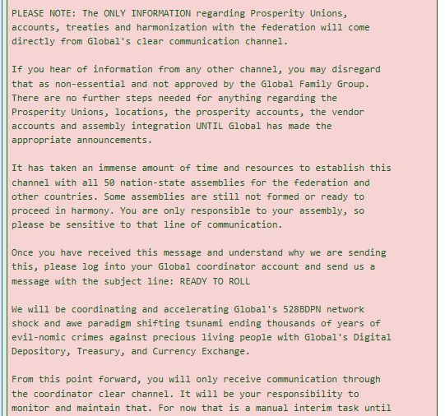

So The Assembly has determined that a person in authority, State Coordinator Sue Hulsebus should be referred to the Oversight Committee:
- The State General Assembly meeting had determined there would be a Banking Committee but there has been no activity to recognize there is one up until 2/24/2025
- State Coordinator has not notified the Assembly and assembled the Banking Committee of the Global Bank letter as of 2/24/2025
- this action is witholding information; thus, exposing the ongoing problem The Assembly has witnessed in other areas including blockading, muting, only holding one meeting a month, withholding information the militia was defunct so our state could not have standing, the disappearance of emails and recordings,
- that Anna Von Reitz stated in a Coordinators Call on Feb 13, 2025 in response to blockading officiates that family members should be thanked and they should move on and that The Assembly was asked to let them know. This response by AVR was not just for “any people”, Anna Von Reitz clearly stated it was for people who were blockading and we only have 4 officiates and the other two, Aaron Lucey and Michelle Schmidt are not blockading anyone,
-Other failures such as not providing an agenda for the state meetings which would have revealed there had been no militia for months. That a cover up occurred by trying to gloss over this fact and other failures by not providing any agenda,
-Using improper venue of State General Assembly to vote on county matters that were already decided by the Clark County to the contrary (Rockie Roper/Denise Mraz/”Pause”) motion by Aaron Eller 2/5/2025,
-That the “pause” motion was plausibly the efforts of a combined number of people,
-That the following Absentia Voting decided on by Sue Hulsebus, despite the people on call desire expressed to vote by hand on 3 motions in person on 2/5, was ignored. This Absentia voting was arbitrarily decided on and then an arbitrary date was placed and then the vote itself was typewritten in a manipulation designed to channel her desired outcome. Everyone was told there would be 2 email one for the vote on Rockie Roper and 1 for the vote to pause Denise. It harmed and demoralized The Assembly,
- All this Voting regarding above in a General Assembly Meeting and motion were undertaken in an improper venue after she had been informed and was responsible for in “The How To Build An Assembly” Book, The Coordinator Handbook and knew it was forbidden,
- Misinforming The Assembly for years that counties could not be stood up with The State and suppressing all positive action of The County through overt control,
- That it is possible other interference that is not 528 hz may be influencing the husband/wife team of Sue and Doug Hulsebus,
-That the original vetting of these individuals may have not recognized all aspects of their background,
- A 1/31 letter to listerserve@nevadaassembly.org was published by Sue Hulsebus and used to denigrate, slander, and malign designed to limit the rights of the The Clark County Assembly to assert their rights to have a safe venue for the purposes of conducting business in an office. Witnesses can attest there was no money, no sensitive records, and the office was established to make The Assembly more accessible to all. And that an office is required for the State and County to stand, but Sue made it her mission to shut it down,
- Allegations were made by State Coordinator in the name of “safety”, but in fact there has been every kind of echo chamber and chaoskraft since Clark County had established an Office of Sheriff November including the adoption of forms designed to cover up that Sue Hulsebus investigated an ASN and that Vetting forms adopted 2/5/2025 made up by “The Four Amigos” Peter Grunfelder, Brian Vonarx, Sue and Doug and possibly a 5th person who may have, had or may hold a defacto license were voted on without pre- requested public comment on the same forms,
Should you need supporting evidence, I would be happy to provide what I have.
Denise Mraz

