﻿
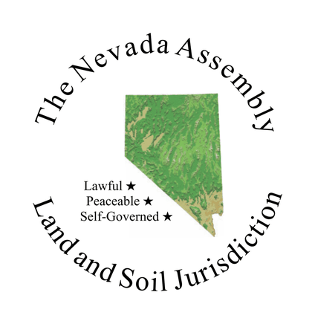
THE NEVADA ASSEMBLY
Nevada Assembly Election
OFFICIAL MEMBER VOTE — VERIFIED MEMBERS ONLY

All verified members of The Nevada Assembly are called to vote on the following Nevada Assembly topic.
◉ Voting closes Saturday, September 26, 2026 · 11:59 PM Pacific
Members have seven days to cast their vote. Please respond by the closing date above.
THE QUESTION BEFORE THE ASSEMBLY
Adoption of the Jural Pillar Seal
The Nevada Assembly is asked to adopt a seal for its Jural pillar, so that the Chief Justice may issue correspondence under a seal of the Jural Assembly rather than under the Assembly’s own.
PROPOSED — THE JURAL PILLAR SEAL
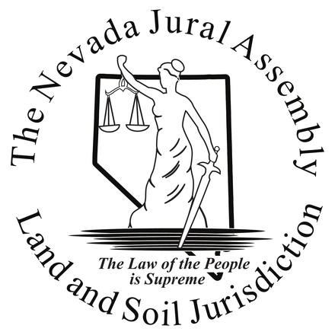
The Law of the People is Supreme
Not seeing the seal? Click here to open it
www.nevadaassembly.org/wp-content/uploads/2026/09/jural-seal-english-outline-440-v2.png

Described in words, for members whose mail does not display images: the figure of Justice, drawn in outline, holding the scales aloft in one hand and a sword lowered in the other, standing before the outline of the State of Nevada. The outer ring carries the legend The Nevada Jural Assembly above and Land and Soil Jurisdiction below. Beneath the figure runs the motto The Law of the People is Supreme.
This design was sent to every member for comment on 4 August 2026. Members asked for two changes: that the figure be drawn with interior line work rather than as a solid silhouette, and that the motto be set in plain English rather than Latin. Both were carried out. Four versions — English and Latin, silhouette and outline — were put before the Jural Assembly, which selected the English motto with the outline figure on 9 September 2026. The selection was then held open for further comment from members listening to the recording, and none was received. It now comes to the whole membership for validation.

ONE SEAL IS BEFORE YOU
This ballot concerns the Jural Pillar Seal only. The Militia Pillar Seal was adopted by the membership on 25 August 2026 and is settled. Nothing you decide here affects it, and nothing here affects the seal of The Nevada Assembly itself.

CAST YOUR VOTE
Select one. Your response is sent to the Assembly and recorded.
✓ YEA
I approve the adoption of the Jural Pillar Seal.
✗ NAY
I do not approve the adoption of the Jural Pillar Seal.
If the buttons do not open your email program, send your vote yourself. Address it to
elections@nevadaassembly.org
with the subject line Validation of the Jural Pillar Seal and the word YEA or NAY in the message.

How this vote is counted. This ballot is held under the validation process The Nevada Assembly adopted on 26 January 2025. Every member on the roll may vote, and no meeting attendance is required. One vote per member. The first vote received from a member is the vote that is recorded; a later message does not replace it. A member who does not return a ballot is recorded as not having voted. The greater number of yea against nay decides the question. The result will be announced to the membership and entered in the validation log.
The Nevada Assembly
Guidelines, Processes and Procedures Committee
1805 N. Carson Street #189, Carson City, Nevada 89701
gpp@nevadaassembly.org · nevadaassembly.org
You are receiving this because you are a verified member of The Nevada Assembly.
Unsubscribe

